Custom Wave Analytics Process

1. **We have our three predefined classes for creating a custom dataset through the batch class.**

Predefined Classes/Interface:

1. Analytics_Interface: contains methods which are defined to be accessed in analytics batch.
2. Analytics_Utilties: contains methods and variables used to create CSV data used for the custom dataset.
3. Analytics_GenericBatch: contains methods used to access the class name of the batch which is defined in the metadata and also defines the size of the batch.
4. **As per the new requirement of the batch, we create a new custom metadata record under the below created metadata in SF**



Details are mentioned as below in the record:

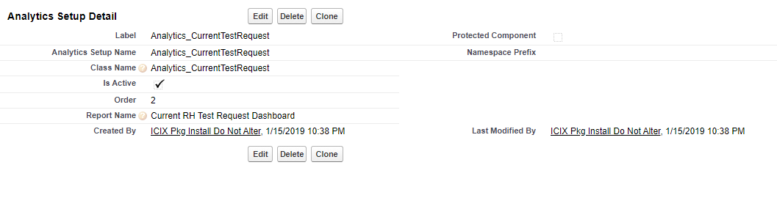

1. **Now, the main batch class suppose Analytics_CurrentTestReport(this class will call all the above mentioned classes and interface), the main logic is written in this analytics batch class and also the name of the custom dataset is given in the batch class.**
2. **Once the batch is created, we need to run this batch class to create our new custom dataset. Using the below code we can run the batch class:**

Analytics_GenericBatch batchInstance = new Analytics_GenericBatch(3);

batchInstance.isbatchScheduled = false;

batchInstance.reportOrderProcessed = Integer.valueOf(3);

Database.executeBatch(batchInstance,400);

* Number **3** here denotes the order we defined in the metadata, means which analytics batch should run.
* **400** here denotes the batch size.

1. **Once the above script is executed successfully, the custom dataset is visible in the data manager jobs with the successful notation as below:**



Other than successful message, there can be **warning** (some records not processed successfully) or **Failed** (None record were processed), in such cases we need to debug those issues.

1. **Once the dataset is successfully created, you can create dashboard on the basis of fields and the data fetched in the custom dataset.**